16.29: a) For a stopped pipe, the wavelength of the fundamental standing wave is 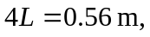and so the frequency is b) The length of the column is half of the original length, and so the frequency of the fundamental mode is twice the result of part (a), or 1.23 kHz.

